Name: MUBARAK MIKAIL

Andrew ID: mmikail

Program: MSIT

Data Inference and Applied Machine Learning

Assignment 5

Q1

1.1 Four steps to implementing a rule-based approach to decision-making are:

1.2 Overfitting
Overfitting refers to a situation whereby a model does well with the train data and fails with the test data. This is very important in Statistical learning as it helps shows how successful our model really is. Simple is better than complex especially when you look at the concept of model parsimony. If a simple model can get the job done and gives us a very good accuracy, it is better to work with that model. The model should not be too simple to avoid underfitting which might make it inflexible to learn from the dataset. However, using all the 10 parameters when they all are not really necessary might not be good for our model as it may tend to decrease the accuracy of the model. Our model shouldn’t also be too complex as it might lead to high varince which may introduce errors to our model. It is important to always start with a simpler model. Occam’s razor test says if two mdels have the same performance, it is better to pick the simpler model.

1.3 Two approaches to avoid overfitting.
- Cross-validation: This involves using your initial training data to generate multiple mini train-test splits. Use these splits to tune your model. Cross-validation allows you to tune hyper parameters with only your original training set. This allows you to keep your test set as a truly unseen dataset for selecting your final model.
- Train your model with more data: Training with more data can help algorithms detect the signal better. This technique might sometimes add noise to the data. Hence, the need to ensure the data is relevant and clean before adding to the model training.

1.4 Two examples of metrics used to evaluate the performance of a model
- Mean Absolute Error :The average of the difference between the Original Values and the Predicted Values. It gives us the measure of how far the predictions were from the actual output.
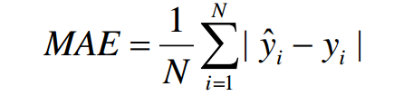

- Mean Squared Error: The average of the square of the difference between the original values and the predicted values
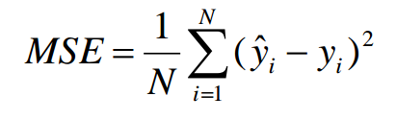

Examples of applications:
- In the case of two or more models that have been fit into a data set, the Mean Absolute Error can be used to estimate the accuracy of the models which can then be used to select the model that will perform best among these models.
- Mean squared error could be used to evaluate the accuracy of a linear regression model and also check for overfitting after testing the model with the test data.

1.5 Benchmarks in Machine learning
Benchmarks are of major importance in machine learning because with benchmarks we can compare how our model performs against a benchmark we trust to a large extent. For newcomers, benchmarks provide a summary that helps them orient in a maze of new terms and data. For sophisticates, benchmarks provide an easily portable and quick-to-collect baseline, where specific measurements will give more relevant data, and disagreement between the benchmark and the specific measurement suggests that more investigation is needed. For users and solution providers, benchmarks provide the possibility of sharing the development costs of measurement infrastructure. Examples of benchmarks include: persistence of a model.

Q2
2.1 Machine learning is the science of deriving knowledge and information from data and prior experience. The evolution of machine learning can be traced as far back as 1950 when Alan Turing postulated that A machine can actually learn, if when we communicate with it, we cannot distinguish it from another human. An employee of IBM, Arthur Samuel wrote ELIZA, the first game-playing program for checkers that achieved sufficient skill to challenge a world champion. In 1957, Frank Rosenblatt of Cornell University invented the perceptron(neural network), a very simple linear classifier. AI came to the fore front in 1990, followed by Big Data in 2010 and Open Data in 2014. It has become really popular because of its applications in today’s world and the enormous datasets being generated today inform of structured and unstructured data. Examples of these include medical diagnosis, driver-less cars and sentiment analysis on social media.

2.2 Three examples of machine learning techniques that can be viewed as either supervised or unsupervised approaches are:
- Estimation
- Evaluation
- Prediction

2.3 Difference between classification and regression
Classification technique provides the predictive model or function which predicts the new data in discrete categories or labels like 1 or 0, true or false, with the help of the historic data. Conversely, the regression method models continuous-valued functions which means it predicts the data in continuous numeric data using the necessary explanatory variable. Decision tree and logistic regression are some of the algorithms used for classification while regression tree and linear regression are used for regression. Classification predicts unordered data while regression predicts ordered data. The significant difference between Classification and Regression is that classification maps the input data object to some discrete labels. On the other hand, regression maps the input data object to the continuous real values.

2.4 Difference between supervised learning and unsupervised learning
Supervised learning is where you have input variables and an output variable and you use an algorithm to learn the mapping function from the input to the output. Unsupervised learning is modeling the underlying or hidden structure or distribution in the data in order to learn more about the data. Unsupervised learning is where you only have input data and no corresponding output variables.
In supervised learning scientist acts as a guide to teach the algorithm what conclusions or predictions it should come up with. In unsupervised learning there is no correct answer there is no teacher, algorithms are left to their own to discover and present the interesting hidden structure in the data.

2.5 Applications of Machine learning

- Online Fraud Detection: Machine learning is proving its potential to make cyberspace a secure place and tracking monetary frauds online is one of its examples. For example: Paypal is using ML for protection against money laundering. The company uses a set of tools that helps them to compare millions of transactions taking place and distinguish between legitimate or illegitimate transactions taking place between the buyers and sellers. This application uses classification algorithm to classify transactions as either fraudulent or not. It does supervised learning.

- Email Spam and Malware Filtering: There are a number of spam filtering approaches that email clients use. To ascertain that these spam filters are continuously updated, they are powered by machine learning. When rule-based spam filtering is done, it fails to track the latest tricks adopted by spammers. Multi Layer Perceptron, C 4.5 Decision Tree Induction are some of the spam filtering techniques that are powered by ML. The system security programs that are powered by machine learning understand the coding pattern. Therefore, they detects new malware with 2–10% variation easily and offer protection against them. This application uses classification algorithm to filter emails either that might contain malware. It does supervised learning as the system would have been trained with a large labeled dataset.

- Virtual Personal Assistants: Siri, Alexa, Google Now are some of the popular examples of virtual personal assistants. As the name suggests, they assist in finding information, when asked over voice. All you need to do is activate them and ask the questions. For answering, your personal assistant looks out for the information, recalls your related queries, or send a command to other resources (like phone apps) to collect info. You can even instruct assistants for certain tasks like “Set an alarm for 6 AM next morning”, “Remind me to visit Visa Office day after tomorrow”.
Machine learning is an important part of these personal assistants as they collect and refine the information on the basis of your previous involvement with them. Later, this set of data is utilized to render results that are tailored to your preferences. This systems utilize supervised learning. Machine Learning is the base of these personal assistants as they get input and gives the output ( based on the previous involvement) in the form of the result according to your requirements.

Q3
3.1 The diabetes data was loaded into Matlab. A correlation matrix of the explanatory variables was derived using the corrcoef function. Functions imagesc and colorbar were then used to create a
heat-map of the matrix which is shown below.

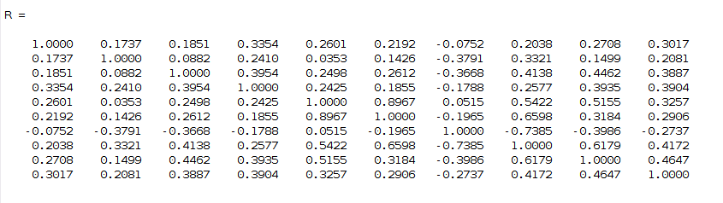
Correlation Matrix of explanatory variables.
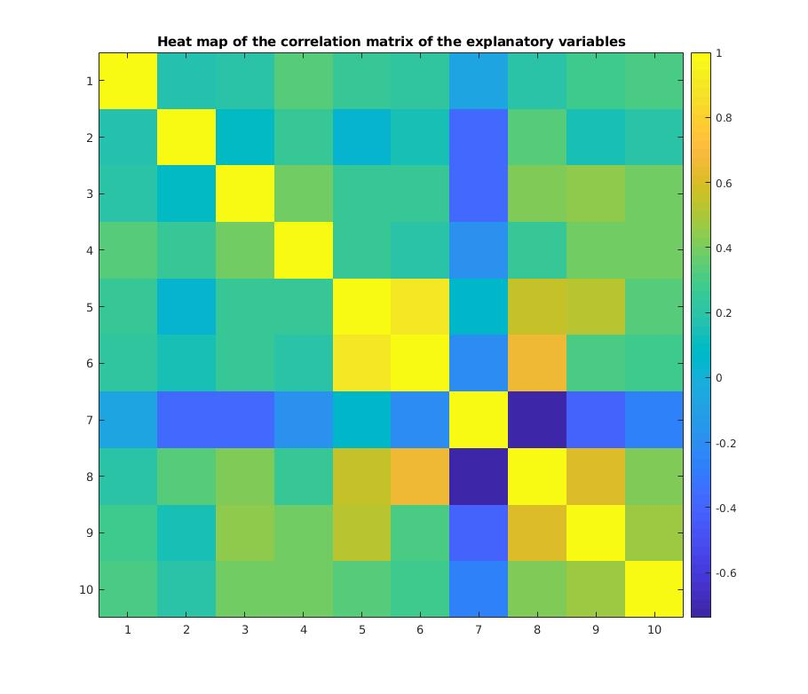
Heat map of correlation matrix of explanatory variables.
As shown from the heat map above, we can see there is a strong relationship between some variables while some have a weak relationship.

3.2 Collinearity
Collinearity is a phenomenon in which one predictor variable in a multiple regression model can be linearly predicted from the others with a substantial degree of accuracy. When predictor variables in the same regression model are correlated, they cannot independently predict the value of the dependent variable. In other words, they explain some of the same variance in the dependent variable, which in turn reduces their statistical significance. Collinearity among predictor variables have an effect on their estimated coefficient value in the sense that the coefficient estimates of the multiple regression may change erratically in response to small changes in the model or the data.

3.3
A multivariate model was created using all ten variables with the fitlm function. The model is given below.

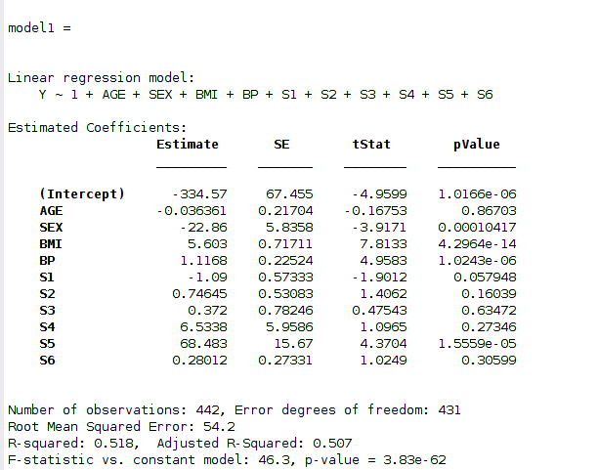

Mean Squared Error for this model is 2932.7 and the Adjusted R² is 0.507.
Not all variables are significant in this model as some variables have a high p-value. It might be due to collinearity among the predictor variables.
3.4 Difference between forward selection and backward selection
Forward selection begins with no variables selected. In the first step, it adds the most significant variable. At each subsequent step, it adds the most significant variable of those not in the model, until there are no variables that meet the criterion set by the user. Backward selection begins a full model with all the variables selected, and removes the least significant one at each step, until none meet the criterion.

3.5
Stepwise regression is a systematic method for adding and removing variables from a multilinear model based on their statistical significance in a regression. The approach stepwise works by generating a model in a step wise manner that is it does a forward selection by adding each of the predictor variables one by one and ends up keeping the most significant predictor variables and removing the least significant ones. After this is completed, it would have selected the most significant predictor variables for predicting the response variable.
The variables selected as shown below are: SEX, BMI, BP, S1, S2 and S5.

The stepwise function begins with an initial model and then compares the explanatory power of incrementally larger and smaller models. At each step, the p value of an F-statistic is computed to test models with and without a potential term. If a term is not currently in the model, the null hypothesis is that the term would have a zero coefficient if added to the model. If there is sufficient evidence to reject the null hypothesis, the term is added to the model. Conversely, if a term is currently in the model, the null hypothesis is that the term has a zero coefficient. If there is insufficient evidence to reject the null hypothesis, the term is removed from the model. The method proceeds as follows:

Fit the initial model.
If any terms not in the model have p-values less than an entrance tolerance (that is, if it is unlikely that they would have zero coefficient if added to the model), add the one with the smallest p value and repeat this step; otherwise, go to step 3.
If any terms in the model have p-values greater than an exit tolerance (that is, if it is unlikely that the hypothesis of a zero coefficient can be rejected), remove the one with the largest p value and go to step 2; otherwise, end.
Depending on the terms included in the initial model and the order in which terms are moved in and out, the method may build different models from the same set of potential terms. The method terminates when no single step improves the model. There is no guarantee, however, that a different initial model or a different sequence of steps will not lead to a better fit. In this sense, stepwise models are locally optimal, but may not be globally optimal.

The MSE and R-squared of this model are given below:
MSE = 2843.8
R² = 0.514884.

The final output of the stepwise function is given below.
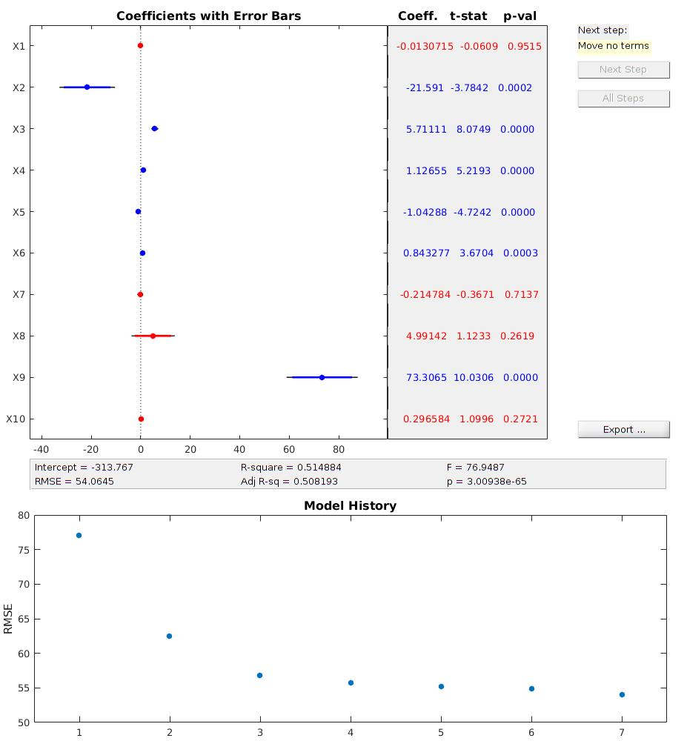

Q4

4.1 Difference between logistic regression and linear regression.
Logistic regression is a classification technique unlike linear regression which is a regression technique as it tries to fit in a linear model on the datasets thereby being able to predict values with some level of accuracy. Logistic regression will typically involve trying to do a binary classification of a variable. Linear regression could be used for classification sometimes, however it is not advisable as it can be broken easily with the addition of outlier datasets.

4.2 The titanic datasets was loaded into Matlab to calculate probability of survival for each passenger on the titanic. Probability of a passenger surviving on the Titanic is 0.3820. This was calculated in Matlab by dividing the number of passengers who survived by the number of total passengers.

4.3 Table giving survival probabilities broken down by passenger class, gender and age.

Variables | Sub Variable | Survival probability
Class | Class 1 | 0.6192
Class | Class 2 | 0.3684
Class | Class 3 | 0.5604
Gender | Male | 0.1910
Gender | Female | 0.4021
Age group | 0 – 10 | 0.5814
Age group | 11 – 20 | 0.3926
Age group | 21 – 30 | 0.3702
Age group | 31 – 40 | 0.4218
Age group | 41 – 50 | 0.4031
Age group | 51 – 60 | 0.4762
Age group | 61 – 70 | 0.2222
Age group | 71 – 80 | 0.4000

4.4
A logistic regression model was built using the fitglm function in matlab. The model is shown below with the parameter estimates.

Looking at the p-value of the parameter estimates from the model, they are very low. We can say that this parameters are statistically significant.

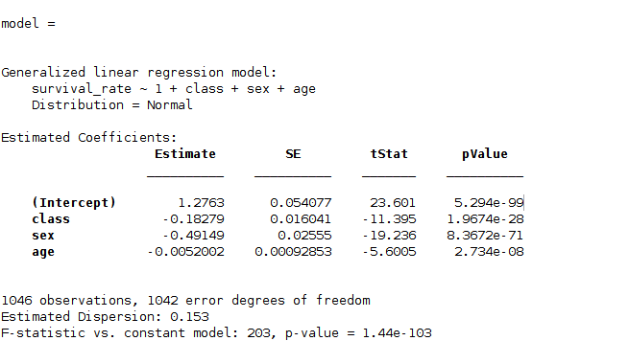

4.5

Confusion matrix was estimated using confusionmat function in matlab. The confusion matrix is given below:
524 95
133 294

Accuracy: ACC = (TP + TN)/(TP+FN + FP+TN)

Accuracy = 0.782.
The accuracy is a bit high and we can say the peformance of the model is good.

REFERENCES
[1]"Overfitting in Machine Learning: What It Is and How to Prevent It", EliteDataScience, 2019. [Online]. Available: https://elitedatascience.com/overfitting-in-machine-learning. [Accessed: 02- Nov- 2019].
[2]"Difference Between Classification and Regression (with Comparison Chart) - Tech Differences", Tech Differences, 2019. [Online]. Available: https://techdifferences.com/difference-between-classification-and-regression.html. [Accessed: 02- Nov- 2019].
[3]"Metrics to Evaluate your Machine Learning Algorithm", Medium, 2019. [Online]. Available: https://towardsdatascience.com/metrics-to-evaluate-your-machine-learning-algorithm-f10ba6e38234. [Accessed: 02- Nov- 2019].
[4]"Supervised Learning vs Unsupervised Learning - Best 7 Useful Comparison", EDUCBA, 2019. [Online]. Available: https://www.educba.com/supervised-learning-vs-unsupervised-learning/. [Accessed: 02- Nov- 2019].

